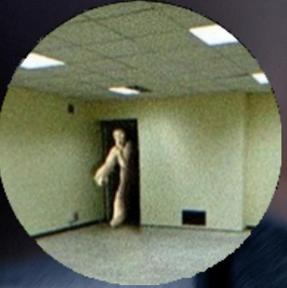
BACKROOM AND MALENA KI PICTURE MENTION KARDI HAI
BAQI JOE AND IRWAN KI KOI SI BHI UTHALOU FOLDER SAI
xxxxxxxxxxxxxxxxxxxxxxxxxxxxxxxxxxxxxxxxxxxxxxxxxxxxxxxxxxxxxxxxxxxxxxxxx
Backroom Archive
UK
"Brilliant experience working with them! They took care of YouTube automation and editing effortlessly, delivering polished, engaging videos that made a real difference. Truly reliable and skilled!"
JOE
DUBAI
"An absolute pleasure to work with! They developed a clear and effective content strategy while delivering top-notch artwork that exceeded my expectations. Their creativity, professionalism, and attention to detail truly set them apart."

Malena
USA
Amazing experience working with them! They set up an automated flow on Power Automate flawlessly, streamlining my processes and saving me so much time. Highly skilled and dependable

IRWAN
Indonesia
Exceptional work! They set up seamless email automation systems that saved me time and improved efficiency. Their expertise, attention to detail, and professionalism made a real difference in my business operations
Xxxxxxxxxxxxxxxxxxxxxxxxxxxxxxxxxxxxxxxxxxxxxxxxxxxxxxxxxxxxxxxxxxxxxxxxxxxxxxxxxxxxxxxxxx
#IN DONO KO REPLACE KARDO WEBSITE KA ORIGINAL TEXT

Genuine feedback from those who matter most—our valued clients

What Our Clients Say:
Real Experiences, Real Impact

